MANUAL 5 Rules, Regulations, Instructions, Manuals and Records for
discharging functions

NATIONAL INSTITUTE OF RURAL DEVELOPMENT
Rajendranagar, Hyderabad - 500 0030.
*****

MEMORANDUM OF ASSOCIATION

1. *The name of the Society will be "the National Institute of Rural Development".

2. The registered office of the Society shall be at Hyderabad in the State of Andhra Pradesh.

3. PREAMBLE

The NIRD will be an apex Institute of Training and Research in the field of Rural Development. It is to be a centre of excellence and to provide the necessary support to the national and state governments and other agencies concerned with rural development in the areas of policy formulation, programme initiatives. Implementation strategies, training, research evaluation, documentation and dissemination of information.

The objects for which the Society is formed are to provide for and promote the study of Rural Development, in all its aspects, in India and with this purpose;

(a) to undertake and assist in the organisation of training and study-courses, conferences, seminars and lectures, incorporating latest methodologies of the Training and instruction including distance education methodologies;

(b) to undertake, aid, promote and coordinate training, research and action research through
its own or other agencies including non-governmental organisations, universities and
other academic institutions and training centres including those established by or with the aid of the Government of India;

(c) to establish schools/centres for (i) Study and orientation, (ii) Training and instruction, and (iii) Research and Evaluation, and such others activities as may be necessary to achieve the objects of the Society;

(d) to analyse specific problems encountered in the planning and implementation of community development, panchayati raj and other rural development programmes, especially those designed to promote the interests of vulnerable sections including women, and propose solutions thereto;

(e) to follow up in a manner to be mutually agreed upon, the training programmes organised by the Training Centres referred to in (b) above and to advise the Ministry of Rural Areas and Employment and subject again to mutual agreement, any other Ministries or authorities on their training programmes.

(f) to prepare, print and publish papers, periodicals and books in furtherance of the objects of the Society;

(g) to establish and maintain Libraries and information services, and information clearing house in all matters relating to Rural Development. It will also function as National Repository in Rural Development Literature;

(h) to collaborate with other institutions, Association and Societies in India and abroad interested in similar objects;

(i) to offer Fellowships, Scholarships, Prizes and Stipends in furtherance of the objects of the Society; and

(j) to promote application of science and technology in the development of rural areas through training research and action research.

(Revised vide Office Order No.42, dated 5th April, 1999).

4. Pursuant to the aforesaid objects, the Society shall take over all the assets and liabilities of the present unregistered society known as *National Institute of Community Development which society was established on 12th February, 1962 by the Ministry of Community Development and Cooperation, Government of India and may:

(a) accept grants of money, securities or property of any kind and undertake and accept the management of any endowment, trust, fund or donation not inconsistent with the objects of the Society, on such terms as may be prescribed by the Government of India from time to time.

(b) invest and deal with funds and monies of the Society;

(c) impose and recover fees and charges for the services rendered by it;
(d) purchase, hire, take on lease, exchange or otherwise acquire a property movable or immovable, which may be necessary or convenient for the purpose of the Society and construct, alter and/or maintain such buildings and works, as may be necessary for carrying out the objects of the Society.

(e) sell, hire, lease, exchange or otherwise transfer or dispose of all or any property, movable or immovable, of the society, provided that for the transfer of immovable property prior approval in writing of the Government of India is obtained;

(f) borrow and raise monies on mortgages, promissory notes or other securities founded or based upon all or any of the properties and assets of the Society or without any securities, provided that prior approval in writing of the Government of India is obtained in that behalf;

(g) draw, accept, make, endorse, discount and deposit Government of India and other promissory notes, bills of exchange, cheques or other negotiable instruments;

(h) create Reserve Fund, Sinking Fund, Insurance Fund or any other special fund whether for depreciation, repairs improvement, extension or maintenance of any of the properties or rights of the Society and/or for recouping wasting assets and for any other purposes for which the society deems it expedient or proper to create or maintain any such Fund or Funds.

(i) create administrative, technical, ministerial and other posts in the Society make appointments and thereto in accordance with the Rules and Regulations of the Society, provided that creation of and appointment to posts carrying a maximum pay of Rs.2,000/- or more per month shall require the prior concurrence of the Government of India.

(j) establish a Provident Fund for the benefit of the staff of the Society or any sections thereof;

(k) make rules and bye-laws for the conduct of the affairs of the society and add to, amend vary or rescind them from time to time.

(l) do all such other acts and things either alone or inconjunction with other organisations or persons as the Society may consider necessary incidental or conducive to the attainment of the above objects.

5. The Society shall with effect from the date of it is registered under the Public Societies Registration Act I of 1350 F. be deemed to have been entrusted with the functions of the National Institute of Community Development established by letter dated 12.2.1962 of the Ministry of Community Development and Cooperation, Government of India.
6. The names, occupations, and addresses of the first members of the Executive Council to whom by the Rules of the Society, the management of its affairs is entrusted are as follows:

================================================================
Sl. Name Occupation Address
No.
----------------------------------------------------------------

1. Shri S.N.Mozumdar Retd.I.C.S. A-60,Kailash
Colony,New Delhi.

2. Dr.George Jacob I.A.S. Principal, National
Institute of Community
Development, Hyderabad.

3. Shri I.D.N.Sahi I.C.S. Addl. Secretary to
Government of India,
Ministry of CD & Coop.,
New Delhi.

4. Shri S.Vasudevan I.A.S. Jt. Secretary to the
Government of India,
Ministry of Finance,
New Delhi.

5. Shri S.Govindrajulu Educationist 16, Barnaby Road
Kilpauk, Madras - 10.

6. Shri C.Narasimham Retd. I.A.S. Managing Director
Food Corporation of
India, Madras.

7. Dr.J.N.Khosla Educationist Director, Indian
Institute of Public
Administration
Ring Road, East
New Delhi.

8. Shri K.S.V.Raman Retd. I.C.S. 400, Canal Boring Road,
Patna - 1.

9. Shri T.S.Avinashi- Educationist Ramakrishna Mission
lingam Vidyalaya,
Coimbatore.

10. Dr.J.S.Patel Educationist Vice-Chancellor
Agricultural Univer-
sity, Jabalpur.

11. Prof. M.V.Mathur Educationist Vice-Chancellor
University of
Rajasthan, Jaipur.

7. All property of the Society, movable or immovable shall vest in the Executive Council.

8. The income and property of the Society howsoever derived, shall be applied towards the promotion of the objects as set forth in this Memorandum of Association subject, nevertheless, in respect of expenditure of grants made by the Government of India to such direction as the Government of India may from time to time give. No portion of the income and property of the Society shall be paid or transferred directly or indirectly by way of dividend, bonus or otherwise howsoever by way of profit to persons who at any time are or have been members of the society, or to any of them or to any persons claiming through them or
any of them, provided that nothing herein shall prevent the payment in good faith of remuneration to any member or other person in return for service rendered to the Society or for travelling allowance, halting allowance and other similar charges.

9. If on the winding up or dissolution of the Society, there shall remain after the satisfaction of its debts and liabilities any property whatsoever, the same shall not be paid to or distributed among the members of the Society or any of them, but shall be dealt with in the manner provided by section 12 of the Public Societies Registration Act 1350 F.

10. A copy of the Rules and Regulations of the Society certified to be correct by three members of the Executive Council is filed with the Registrar of Societies, Hyderabad along with the Memorandum of Association.

We, the several members whose names and addresses are given below, having associated ourselves for the purpose prescribed in this Memorandum of Association, do hereby subscribe our names to this Memorandum of Association and set our several and respective hands here unto and form ourselves into a Society under the Public Societies Registration Act I of 1350 F. this first day of November 1965 at Hyderabad.

================================================================

Sl. Name, addresses and occupation of members Signature of
No. members
----------------------------------------------------------------

1. Shri S.N.Mozumdar, Retd. ICS., Sd/-
A-60, Kailash Colony, New Delhi.

2. Dr.G.Jacob, IAS., Principal, Sd/-
National Institute of Community
Development, Hyderabad.

3. Shri I.D.N.Sahi, ICS., Addl. Secretary Sd/-
to the Government of India, Ministry of
CD & C., New Delhi.

4. Shri S.Vasudevan, IAS., Jt. Secretary Sd/-
to the Government of India, Ministry of
Finance, New Delhi.

5. Dr.J.N.Khosla, Educationist, Sd/-
Director, Indian Institute of Public
Administration, Ring Road, East,
New Delhi.

WITNESSES:

1. Sd/- Shri T.R.Satish Chandran 2. Sd/- Shri S.K.Patil
Deputy Secretary to the Under Secretary
Government of India, to Government
Ministry of Community of India,
Development & Coop., Ministry of CD
New Delhi. & Coop.,
New Delhi.

================================================================

*****

RULES OF
THE NATIONAL INSTITUTE OF RURAL DEVELOPMENT 1991.

I. Short Title and Commencement

These rules may be called "Rules of the National Institute of Rural Development, 1991".

They shall come into force on .............

II. Definitions

(i) "The Institute" means the "National Institute of Rural Development".

(ii) "The General Council" means the General Council of the Institute.

(iii) "The Executive Council" means the Executive Council of the Institute.

(iv) "The President" means the President of the Institute.

(v) "The Vice-President" means the Vice-President of the Institute.

(vi) "Rules" means any of the Rules and Regulations of the Institute.

III. Constitution of the Institute

The Institute shall consist of the following members namely:

1. The President of the : The Minister in-charge of the
Institute Ministry/Department,
Government of India dealing
With the Institute.

2. Two Vice-Presidents : 1. Minister of State for Rural
of the Institute Development looking after
the subject in the
Ministry

2. Secretary to the Government
of India in the Department
of Rural Development.

3. Four persons from : To be appointed by the President
non-official Institu- of the Institute.
tions in India working
in rural development/re-
construction and allied
fields.

4. Nine eminent persons who have made noteworthy contribution in the field of rural development including one or two non-officials functioning of Zilla Parishad level with long experience.

5. One person each from the All India Panchayat Parishad and the National Cooperative Union.

6. Chairman of the University Grants Commission, President, Association of Indian Universities.

7. "Secretary (DWS), Joint Secretary as well as Financial Adviser in the Ministry/Department of Rural Development, Government of India dealing with the Institute and Secretary in the Ministry of Agriculture".

8. "Secretaries in the Ministries of Education and Welfare Department of Personnel & Training and Planning Commission or their nominee not below the rank of Joint Secretary".

9. Five Secretaries to State Governments Union Territories in charge of Rural Development/Reconstruction or Development Commissioners, in rotation.

10. Seven members of the Union, State and Union Territory Legislatures; 2 from Lok Sabha, 1 from Rajya Sabha, 4 from State and Union Territories (to represent four Zonal Councils by rotation).

11. Three Vice-Chancellors of Universities.

12. Three academic staff members of the Institute - one Director, one Deputy Director and one Assistant Director and also one representative of the non-academic staff to be nominated by the Director General, by rotation, each one holding the office for a period of two years.

13. The Director General of the Institute.
(Revised vide Office Order No.944, dated 28th February,
2003).

IV. Roll of Members

The Institute shall keep a Roll of Members giving their occupations and addresses and every member shall sign the same. If a member of the Institute changes his address, he shall notify his new address to the Director General, who shall thereupon cause his new address to be entered in the Roll of Members. If the member fails to notify his address, the address given in the Roll of Members shall be deemed to be his address.

V. Terms of Office

(i) The term of office of members mentioned in clauses 5, 9, and 10, Rule III shall be for three years, at the expiry of which period the organization or the Ministry concerned may nominate the same person or some other person in their places. In the case of any vacancy arising earlier than the stipulated period of three years, the organization or the Ministry concerned may nominate any other person for the unexpired portion of the term.

(ii) The members of the Institute specified in clauses 3 and 4 of Rule III shall be appointed in the first instance by the Government of India for a period of three years. In the case of any vacancy arising earlier than the stipulated period of three years, the Government of India shall nominate any other person for the unexpired portion of the term. At the end of the three year period, one third of such members or as nearly as may be, shall retire in rotation every year and shall be eligible for renomination provided that no member shall serve for more than two consecutive terms. The vacancies so caused shall be filled by the Government of India.

(iii) A member of the Institute may resign his membership by a letter addressed to the Director General. The resignation shall take effect from the date of its acceptance by the President or from the thirtieth day following the date of receipt of the letter by the Director General, whichever is earlier.

(iv) A member of the Institute shall cease to be a member if he becomes insolvent or of unsound mind or is convicted of a criminal offence involving moral turpitude.

VI. Officers of the Institute

The following shall be the officers of the Institute namely:

(i) President

(ii) Vice Presidents

(iii) Director General and

(iv) Such other officers as the Executive Council may from time to time appoint.

VII. Director General

The Director General shall be appointed by the Executive Council with the prior approval of the Government of India. He shall receive such salary and emoluments and will be governed by such terms and conditions of service as the. Executive Council may determine from time to time with the prior approval of the Government of India.

VIII. The General Council

(i) There shall be a General Council of the Institute and it shall be composed of all the members of the Institute;

(ii) The annual general meeting of the General Council shall be held at such date, time and place as may be determined by the President;

(iii) The General Council shall meet at least once every year;

(iv) For the purpose of the last sub-rule, each year shall be deemed to commence on the first day of April and terminate on the thirty first day of March of the following Calendar year;

(v) The President may convene a special meeting of the General Council whenever he thinks fit, and shall do so on the written requisition of not less than one third of the members of the Institute;

(vi) Every notice calling a meeting of the General Council shall state the date, time and place at which such meeting will be held and shall be served upon every member of the General Council not less than twenty one clear days before the day appointed for the meeting;

(vii) The accidental omission to give notice to, or the non-receipt of notice by, any member or other person, to whom it should be given, shall not invalidate the proceedings at the meeting;

(viii) In the absence of the President, the Minister in charge of Rural Development or related subject or in his absence, the Secretary to Government of India in the Department of Rural Development, who are Vice-President shall preside.

(ix) Nine member of the General Council present in person shall form a quorum. No quorum shall be required for an adjourned meeting;

(x) All disputed questions at meetings of the General Council shall be determined by vote;

(xi) Each member of the Institute shall have one vote;

(xii) In case of an equality of votes the person presiding over the meeting shall, in addition, have a casting vote;

(xiii) The president may invite any person other than a member, to attend a meeting of the General Council, such invitee shall not, however, be entitled to vote at the meeting;

(xiv) The General Council shall function notwithstanding any vacancy therein and notwithstanding any defect in the appointment, nomination or election of any member and no act or proceedings of the General Council shall be invalidated or nullified merely by reason of the existence of any vacancy therein or any defect in the appointment, nomination or election of any member; and

(xv) Where for any reason it is not possible for the General Council to meet, any business which it may be necessary for the General Council to perform may be carried out by taking the approval of the President after due recommendation by the Executive Council, provided that the ex-post-facto approval of the General Council shall be obtained at its next meeting.

IX. Functions and Powers of General Council

The General Council shall have the following powers and functions, namely, to:-

(i) Observe the Provisions of the Memorandum of Association, these Rules and such instructions of the Government of India in the Department;

(ii) Exercise general control and issue such directions for the efficient management and administration of the affairs of the Institute as may be necessary;

(iii) Nominate members of the Executive Council in accordance with clause (i) of Rule X;

(iv) Approve the annual budget of the Institute for submission to the Government of India for sanction of Government Grants;

(v) Consider the Annual Report and audited Annual Accounts, of the Institute for the immediately preceding financial year along with the Audit Certificate, the Audit Report, and replies of the Institute to the observations contained in the Audit Report;

(vi) Add to, amend, vary or rescind, with the prior approval of the Government of India, any of these rules:

(vii) Frame Bye-laws not inconsistent with these Rules and the Memorandum of Association, for the management, administration and regulation of the business of the Institute for the furtherance of its objects;

(viii) Constitute an Academic Committee to advise on all Academic matters, i.e., matters relating to training, research and action research, and such standing committees as required, with or without the power of co-opt, for disposal of any business of the Institute or for advice on any matter pertaining to the Institute; and
(ix) Perform such other functions as are entrusted to it under these Rules.

X. The Executive Council

(i) There shall be an Executive Council of the Institute and it shall consist of the following members;

- Union Minister of Rural Development who is also the President of the General Council shall be the Chairman of the Executive Council.
(Revised vide Office Order No. 578, dated 16th October, 2003)

(b) The Director General of the Institute.

(c) Secretary (RD), Secretary (DWS), Joint Secretary as well as Financial Adviser in the Ministry/Department of Rural Development, Government of India dealing with the Institute.

(d) Five eminent persons who have made note-worthy contributions in the fields of Rural Development, reconstructions and allied subjects, to be nominated by the President of the Institute from among the members of the General Council.

(e) Two members to be nominated by the President of the Institute from among the non-official members of the General Council.

(f) Secretary, Department of Personnel and Training Government of India, New Delhi or his nominee not below the rank of Joint Secretary to Government of India.

(Revised vide Office Order No.944, dated 20th February, 2003).

Provided that in the absence of the President of the Institute, the nomination of members specified in sub-clause (d) and (e) shall be done by the Government of India.

(ii) The term of nominated members of the Executive Council shall be three years but they shall be eligible for re-appointment. If any member of the Executive Council ceases to be a member of the Institute, he shall automatically cease to be member of the Executive Council;

(iii) The Executive Council shall function notwithstanding any vacancy therein and notwithstanding any defect in the appointment or nomination of any member and no act or proceeding of the Executive Council shall be invalidated or nullified by reason only of the existence of any vacancy therein or of any defect in the appointment or nomination of any member;

(iv) Any vacancy amongst the nominated members of the Executive Council arising from death or resignation or otherwise, may be filled by nomination by the President or, in his absence, by the Government of India and the members so nominated shall hold office for the unexpired portion of the term of office of the member causing the vacancy;

- Every meeting of the Executive Council shall be presided over by its Chairman and in his absence, MOS (RD) looking after the subject related to NIRD, and who is also one of the two Vice Presidents of the General Council, shall chair the meeting.

  - In the absence of both the Union Minister and MOS (RD), Secretary (RD) who is also one of the two Vice Presidents of the General Council, shall chair the meeting.
(Revised vide Office Order No. 578, dated 16th October, 2003)

(vi) Four members of the Executive Council present in person shall constitute quorum. No quorum shall be required for an adjourned Meeting;

(vii) For every meeting of the Executive Council not less than fifteen clear days' notice shall be given to each member, provided that the Chairman in special circumstances may call a meeting at a shorter notice;

(viii) At least two meeting of the Executive Council shall be held every year;

(ix) For the purpose of the last sub-rule, each year shall be deemed to commence on the first day of April and terminate on the thirty-first day of March of the following calendar year;

(x) The Chairman of the Executive Council may himself call, or by a requisition in writing signed by him may require the Director General to call a meeting of the Executive Council at any time;

(xi) Each member of the Executive Council, including the Chairman thereof shall have one vote and in case there shall be an equality of votes on any question to be decided by the Executive Council, its Chairman or in his absence the person presiding over the meeting shall, in addition, have a casting vote;

(xii) The Chairman of the Executive Council may invite any person, other than a member to attend a meeting of the Executive Council. Such invitee shall not, however, be entitled to vote at the meeting; and

(xiii) Any business which it may be necessary for the Executive Council to perform may be carried out by circulation of papers among all its members and any resolution so circulated and approved by a majority of the members signing shall be as effectual and binding as if the resolution had been passed at a meeting of the Executive Council provided that at least six members have recorded their views on the resolution.

XI. Functions and Powers of the Executive Council

(i) Subject to the general control and direction of the General Council, the Executive Council shall be responsible for the management and administration of the affairs of the Institute in accordance with these rules and the Bye-laws made there under for the furtherance of its objects and shall have all powers-administrative and financial which may be necessary or expedient for the purpose.

(ii) Without prejudice to the generality of the foregoing sub-rule, the Executive Council shall have the following powers and functions, namely to:

(a) Prepare and execute detailed plans and programmes for the furtherance of the objects of the Institute;

(b) Create such posts, appoint and control such staff other than those for whose appointment specific provision has been made elsewhere, as may be required for the efficient management of the affairs of the Institute and regulate the terms and conditions of their services;

(c) Receive, have custody of, and deal with the funds and monies of the Institute;

(d) Purchase, hire, take on lease, exchange or otherwise acquire a properly movable or immovable or sell, hire, lease, exchange or otherwise transfer or dispose of all or any property, movable or immovable, of the Institute provided that for the transfer of immovable property the prior approval of the Government of India is obtained in that behalf;

(e) Execute contracts, collaboration agreements, general/special instruments, service agreements, agreements containing arbitration clauses, indemnity bonds, deeds in respect of or connected with sale/lease/license, mortgage, hypothecation or other deeds of a legal character of whatever description, powers of Attorney, enforce any other legal rights and incur legal expenses, provided that these powers are exercised for and on behalf of the Institute;

(f) Sue and defend all legal proceedings on behalf of the Institute;

(g) Appoint Committees, with or without the power to co-opt, for disposal of any business of the Institute or for advice in many matter pertaining to the Institute, provided that in cases of emergency, the Chairman of the Executive Council shall have the power to appoint such committees;

(h) Accept the management of any endowment, trust, fund, subscription or donation, provided that it is not attended by any condition inconsistent, or in conflict, with the objects of the Institute;

(i) Advise the General Council on all matters connected with the budget of the Institute;

(j) Incur expenditure subject to the provisions of the approved budget provided that where, in the opinion of the Chairman, an immediate decision on any matter is essential, he may, within the ambit of operational necessity and efficiency or to meet an emergency, authorise the incurring of expenditure not covered by the provisions of the budget provided that a report would be made to the General Council at its next meeting and its ex-post-facto approval obtained, wherever necessary; and

(k) To lay down terms and conditions governing scholarships, fellowships, deputations, grants-in-aid, research schemes and projects;

(iii) The Executive Council may be resolution delegate to its Chairman, to any Standing Committee, or to the Director General or to any other officer of the Institute, such of its powers for the conduct of business as it may deem fit, subject, if deemed necessary to the condition that the action taken by its own Chairman, the Standing Committee or the Director General, or other officers under the powers so delegated shall be subject to confirmation at the next meeting of the Executive Council.

XII. Standing Committees

1. (a) There shall be two Standing Committees - one dealing with Academic matters called the 'Academic Committee' and another dealing with Selection of Persons called the 'Selection Committee'. Besides these, the Executive Council may appoint Standing Committees for any specific purpose.

(b) The composition and powers of the Standing Committees i.e., the 'Academic Committee' and 'Selection Committee' will be as set out under this Rule. The Standing Committees for specific purposes appointed by the Executive Council shall have term, powers and composition as decided by the Executive Council in each case.

(i) The composition and powers of the 'Academic Committee' are as in Sub-Rule (2) of this Rule.

(ii) Selection Committee

The Director General shall be the Chairman of the 'Selection Committee'. It should consist of the following members:

(a) A representative of the Department of Rural Development, Government of India not below the rank of Joint Secretary.

(b) Two members from among the Members of the Executive Council to be nominated by the Executive Council for such period as may be fixed by the Executive Council but not exceeding three years.

(c) At least one Technical Expert conversant in the relevant subject to be co-opted for each selection by the Director General.

(d) Dy. Director General or Financial Adviser of NIRD.

(e) Every meeting of the Selection Committee shall be presided over by the Director General

OR

in the absence of the Director General, Director General may nominate one of the members of the Selection Committee to preside over any specific meeting.

(iii) Three members of the Selection Committee including the Technical Expert co-opted shall constitute the quorum.

2. ACADEMIC COMMITTEE

(i) The Director General of the Institute shall be the Chairman of the Academic Committee. It shall consist of the following members:

(a) Joint Secretary to the Government of India in the Department of Rural Development dealing with the Institute or his nominee not below the rank of Deputy Secretary - Member.

(b) Two persons from among the members of the Executive Council to be nominated by the Executive Council for such term as may be fixed by the Executive Council but not exceeding 3 years.

(c) Dy. Director General, NIRD - Member.

(d) Financial Adviser, NIRD - Member.

(e) Three heads of Faculties - Members as nominated by the Director General in rotation.

(f) Two nominees of the Planning Commission, Government of India (Research Programme Committee and Programme Evaluation Organisation) for such term as may be fixed by the Executive Council, but not exceeding three years, provided that they are eligible for renomination - Members.

(g) One nominee each of four Institutes in Social Sciences in India selected by the Executive Council for such term as may be fixed by the Executive Council, but not exceeding 3 years.

(h) One non-official who has experience in Rural Development activities to be nominated by the Executive Council for such term as may be fixed by the Executive Council, but not exceeding 3 years.

(i) The Chairman shall co-opt by rotation heads of four State level training Institutes in Rural Development (SIRD or the apex Institution at the State Level declared by the State Government) for such term as may be fixed by him but not exceeding two years.

(j) The Chairman shall have the power to co-opt other members as he considers necessary, including from amongst eminent academicians, academic and research institutions etc. Their cooption would be for a specific meeting of the Academic Committee.
(ii) Every meeting of the Academic Committee shall be presided over by the Chairman (Director General). In the absence of the Chairman, the Academic Committee will elect a Chairman for the specific meeting.

(iii) Nine members of the Academic Committee shall constitute the quorum.

XIII. (1) Powers and functions of the Academic Committee

The Academic Committee shall deal with matters relating to research and training. It shall also function as the Committee on evaluation. It shall deal with matters, proposals or schemes relating to the following subjects initiated by it or referred to it or otherwise.

Training

(i) Annual training programme of the Institute.

(ii) Any other matter relating to training activities of the Institute, such as methodology of training, coverage, course content, syllabus, duration, etc.

Research

(i) Annual research programmes of the Institute.

(ii) Proposals in regard to research studies to be taken up during the year, not included in the annual programme.

(iii) Consultancy research studies and sponsored Collaborative research studies.

(iv) To examine any other matter concerning research and training activities of the Institute.

The Committee shall dispose of finally matters in respect of items for which the Executive Council has delegated its powers under rule XI (iii) of the rules of the Institutes. In all other matters, the Committee shall tender its advice and make recommendations to the Executive Council.

(2) Powers & Functions of 'Selection Committee'

(a) The Selection Committee shall assist the Executive Council/appointing authority concerned in making appropriate selection to Group 'A' posts and any other posts referred to it by the Executive Council.

(b) It can meet at any place in India and adopt such methods as considered appropriate by it to evaluate the relative merits of the candidate offering themselves for the posts. It shall make the recommendations to the Executive Council/appointing authority concerned.

(c) The Appointing Authority concerned shall constitute a Selection Committee, as necessary for other Groups.

XIV. Powers and Functions of the Director General

(i) The Director General as the Principal Executive Officer of the Institute shall be responsible for administration of the affairs of the Institute and shall exercise powers under the direction and guidance of the Executive Council.

(ii) It shall be the duty of the Director General to coordinate and exercise general supervision over all the activities of the Institute.

(iii) Subject to the provisions of sub-clause (i) above, the Director General shall have full powers on behalf of the Institute, to Institute, conduct, intervene, defend, abandon or compound any suit, appeal, review, revision, writ petition or other proceedings by or against the Institute or its employees or otherwise concerning the affairs of the Institute in any court and/or quasi-judicial authorities, to refer any claims or demands by or against the Institute to arbitration and observe and perform the awards, to sign and verify plaints, written statements, execution and other petitions, applications, affidavits, objections, memorandum of appeal or other pleadings to be filed before any judicial or quasi-judicial authorities or arbitrators to enforce judgement, execute any decree or order of any judicial/quasi-judicial authorities or to satisfy the same and/or to realise or withdraw money from any court, persons or other authorities in execution of such decree or order and to sign vakalatnamas, all financial powers as delegated by the Executive Council.

(iv) Subject to the provisions of sub-clause (i) above, the Director General shall be competent on behalf of the Institute to execute contracts, collaboration agreement(s), general/special instruments, service agreements/agreements containing arbitration clauses, indemnity bonds and deeds in respect of/or connected with sale/lease/licence, mortgage, hypothecation, pledge, or other deed(s) of a legal character of whatever description, power(s) of attorney to enforce guarantee(s) or any other legal rights, to incur legal expenses and to act as Agent of the Institute for any purpose whatsoever relating to the affairs of the Institute.

(v) The Director General shall be competent to sub-delegate any of the powers conferred upon him to the Dy. Director General or to such other officers working under him as may be considered necessary, consistent with the need for proper, effective and efficient discharge of responsibilities entrusted to such Dy. Director General/officers.

(vi) In the absence of Director General on long leave, deputation in India or abroad or due to transfer, arrangements to look after the duties of the Director General may be made by the Chairman of the Executive Council.

XV. Funds of the Institute

(i) The funds of the Institute consist of the following:

(a) Grants made by the Central Government or any State Governments;

(b) Donations and contributions from other sources;

(c) Fees and charges imposed by the Institute for services rendered by it;

(d) Income from investments; and

(e) Income and Receipts from other sources.

(ii) (a) The bankers of the Institute shall be any of the Public Sector bank/banks as may be fixed by the Director General.

(b) The Director General or any officer or officers of the Institute working under him as may be authorised by the, the Director General in this behalf, shall be the Drawing and Disbursing Officer of the Institute.

XVI. Powers of the Government

In the discharge of its functions the General Council shall be guided by such directions on question of policy as may be given to it by the Government of India. The decision of the Government of India as to whether a question is or is not a matter of policy shall be final. Such directions shall be in writing.

XVII. Accounts and Audit

(i) The Institute shall cause regular accounts to be kept of all its money and properties in respect of its affairs. The accounts shall be maintained in such form as the Central Government may prescribe.

(ii) The accounts of the Institute shall be audited annually by the Comptroller and Auditor General of India or by any person authorised by him in his behalf and any expenditure incurred in connection with such audit shall be payable by the Institute to the Comptroller and Auditor General of India.

(iii) The Comptroller and Auditor General of India and any person appointed by him in connection with the Audit of the Accounts of the Institute shall have the same rights, privileges and authority in connection with such audit as the Comptroller and Auditor General of India has in connection with the Audit of Government accounts and, in particular, shall have the right to demand the production of books, accounts, connected vouchers and other necessary documents and papers.

(iv) The results of Audit shall be communicated by the Auditor to the Director General as well as to the Department of the Government of India in charge of the Institute.

XVIII. Annual Report

The Annual Report of the proceedings of the Institute including all works undertaken and various achievements made, during a year together with the Audited Annual Accounts (viz., Receipts and Payments Accounts, Income and Expenditure Accounts and Balance Sheet) for the year, the Audit Certificate, the Audit Report and replies of the Institute to the observations contained in the Audit Report shall be placed before the General Council at its next annual general meeting, through the Executive Council.

The General Council shall cause a copy of the Audit Report along with its observations thereon to be submitted to the Government of India after the annual general meeting.

XIX. Office of the Institute

The Office of the Institute shall be at Hyderabad in the State of Andhra Pradesh. The Institute has established its own Regional Centre at Guwahati (Assam) in June, 1983.

XX. Service of Notice

(i) A notice may be served upon any member of the Institute either personally or by post at the address mentioned in the roll of members.

(ii) Any notice so served by post shall be deemed to have been served on the day following that on which it is posted.

XXI. Alteration or Extension of the purpose of the Institute

Subject to the provision of the Public Societies Registration Act I of 1350 F., the General Council may alter, extend or abridge any purpose or purposes for which the society is established.

XXII. Amendment of the Rules

With the previous concurrence of Government of India, with the Rules of the Society may be altered at any time by a resolution when voted by two thirds of the members present at a meeting of the General Council convened for this purpose in accordance with the rules of the Society.

XXIII. As and when there is any change in the nomenclature of the Ministry/Ministries, Department(s), Institution(s) and Designation(s) mentioned in these Rules, such change (s) should automatically stand incorporated in the concerned Rules.

XXIV. Repeal and Savings

The Rules of the National Institute of Rural Development in force prior to the commencement of these Rules are hereby repealed:

Provided that such repeal shall not affect anything done, any order issued, any action taken or any powers exercised before coming into force of the Rules of the National Institute of Rural Development (1991) and all sanctions, orders declarations or other action taken before the commencement of these Rules shall continue to be operative and in force even after the commencement of these Rules, unless specifically cancelled or revoked by the authority who accorded such sanction or issued such order or took such action.

*****

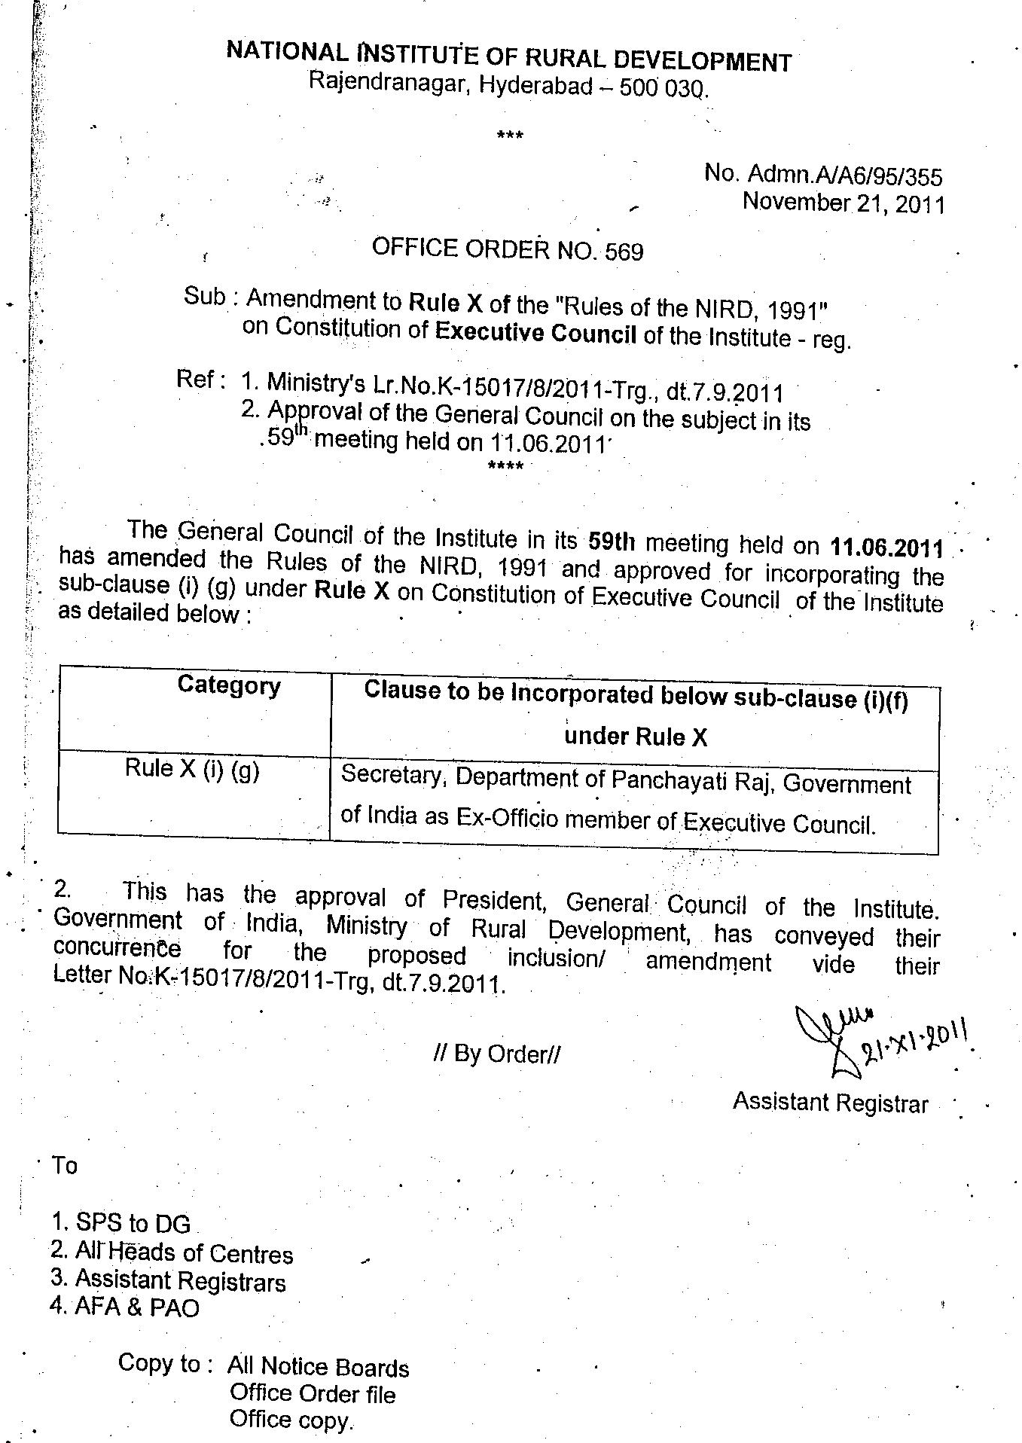

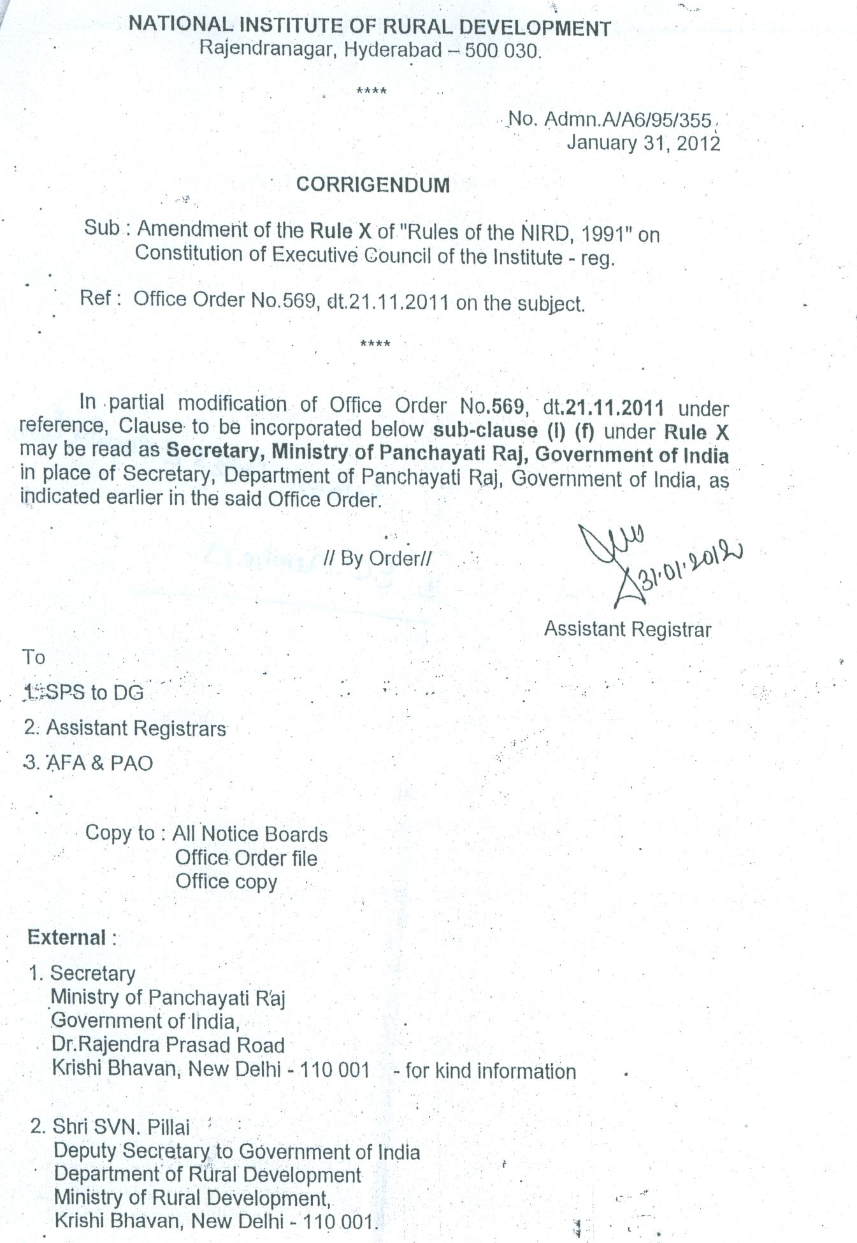

?*The name of the Institute has been changed from National Institute of Community Development to 'National Institute of Rural Development' by the General Council of the Institute at its special meeting held on 20.09.1977.

